Finding Slope from a Graph Name___________________________
Find the slope of the following graphs. Write your answer in the space provided. Once you have answered these three, go to IXL > Alg I > s.2 and practice until you have a 100 smart score! Have Ms. Anselmi sign here x_________________ when you complete IXL.

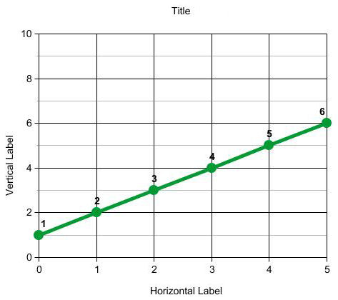
- M =__________

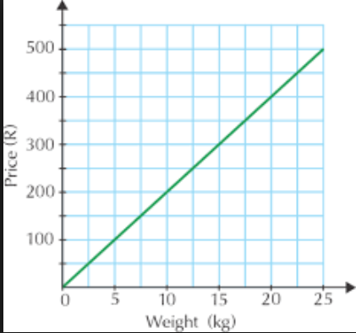
- M = __________

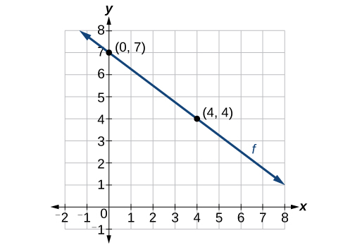

- M = ________

