Solving Multi-Step Equations Name___________________________
Solve for x and JUSTIFY YOUR ANSWERS! Use a separate sheet of paper to show your work!
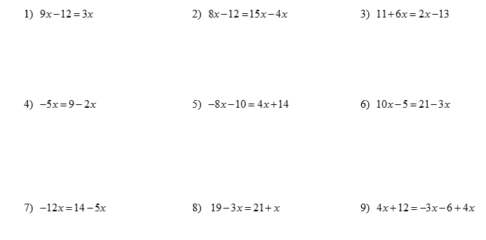

10) $38 + 7k = 8(k + 4)$ 11) $3(1 - 3x) = 2(-4x + 7)$

